**HW5**

201635840 이정명

**1**

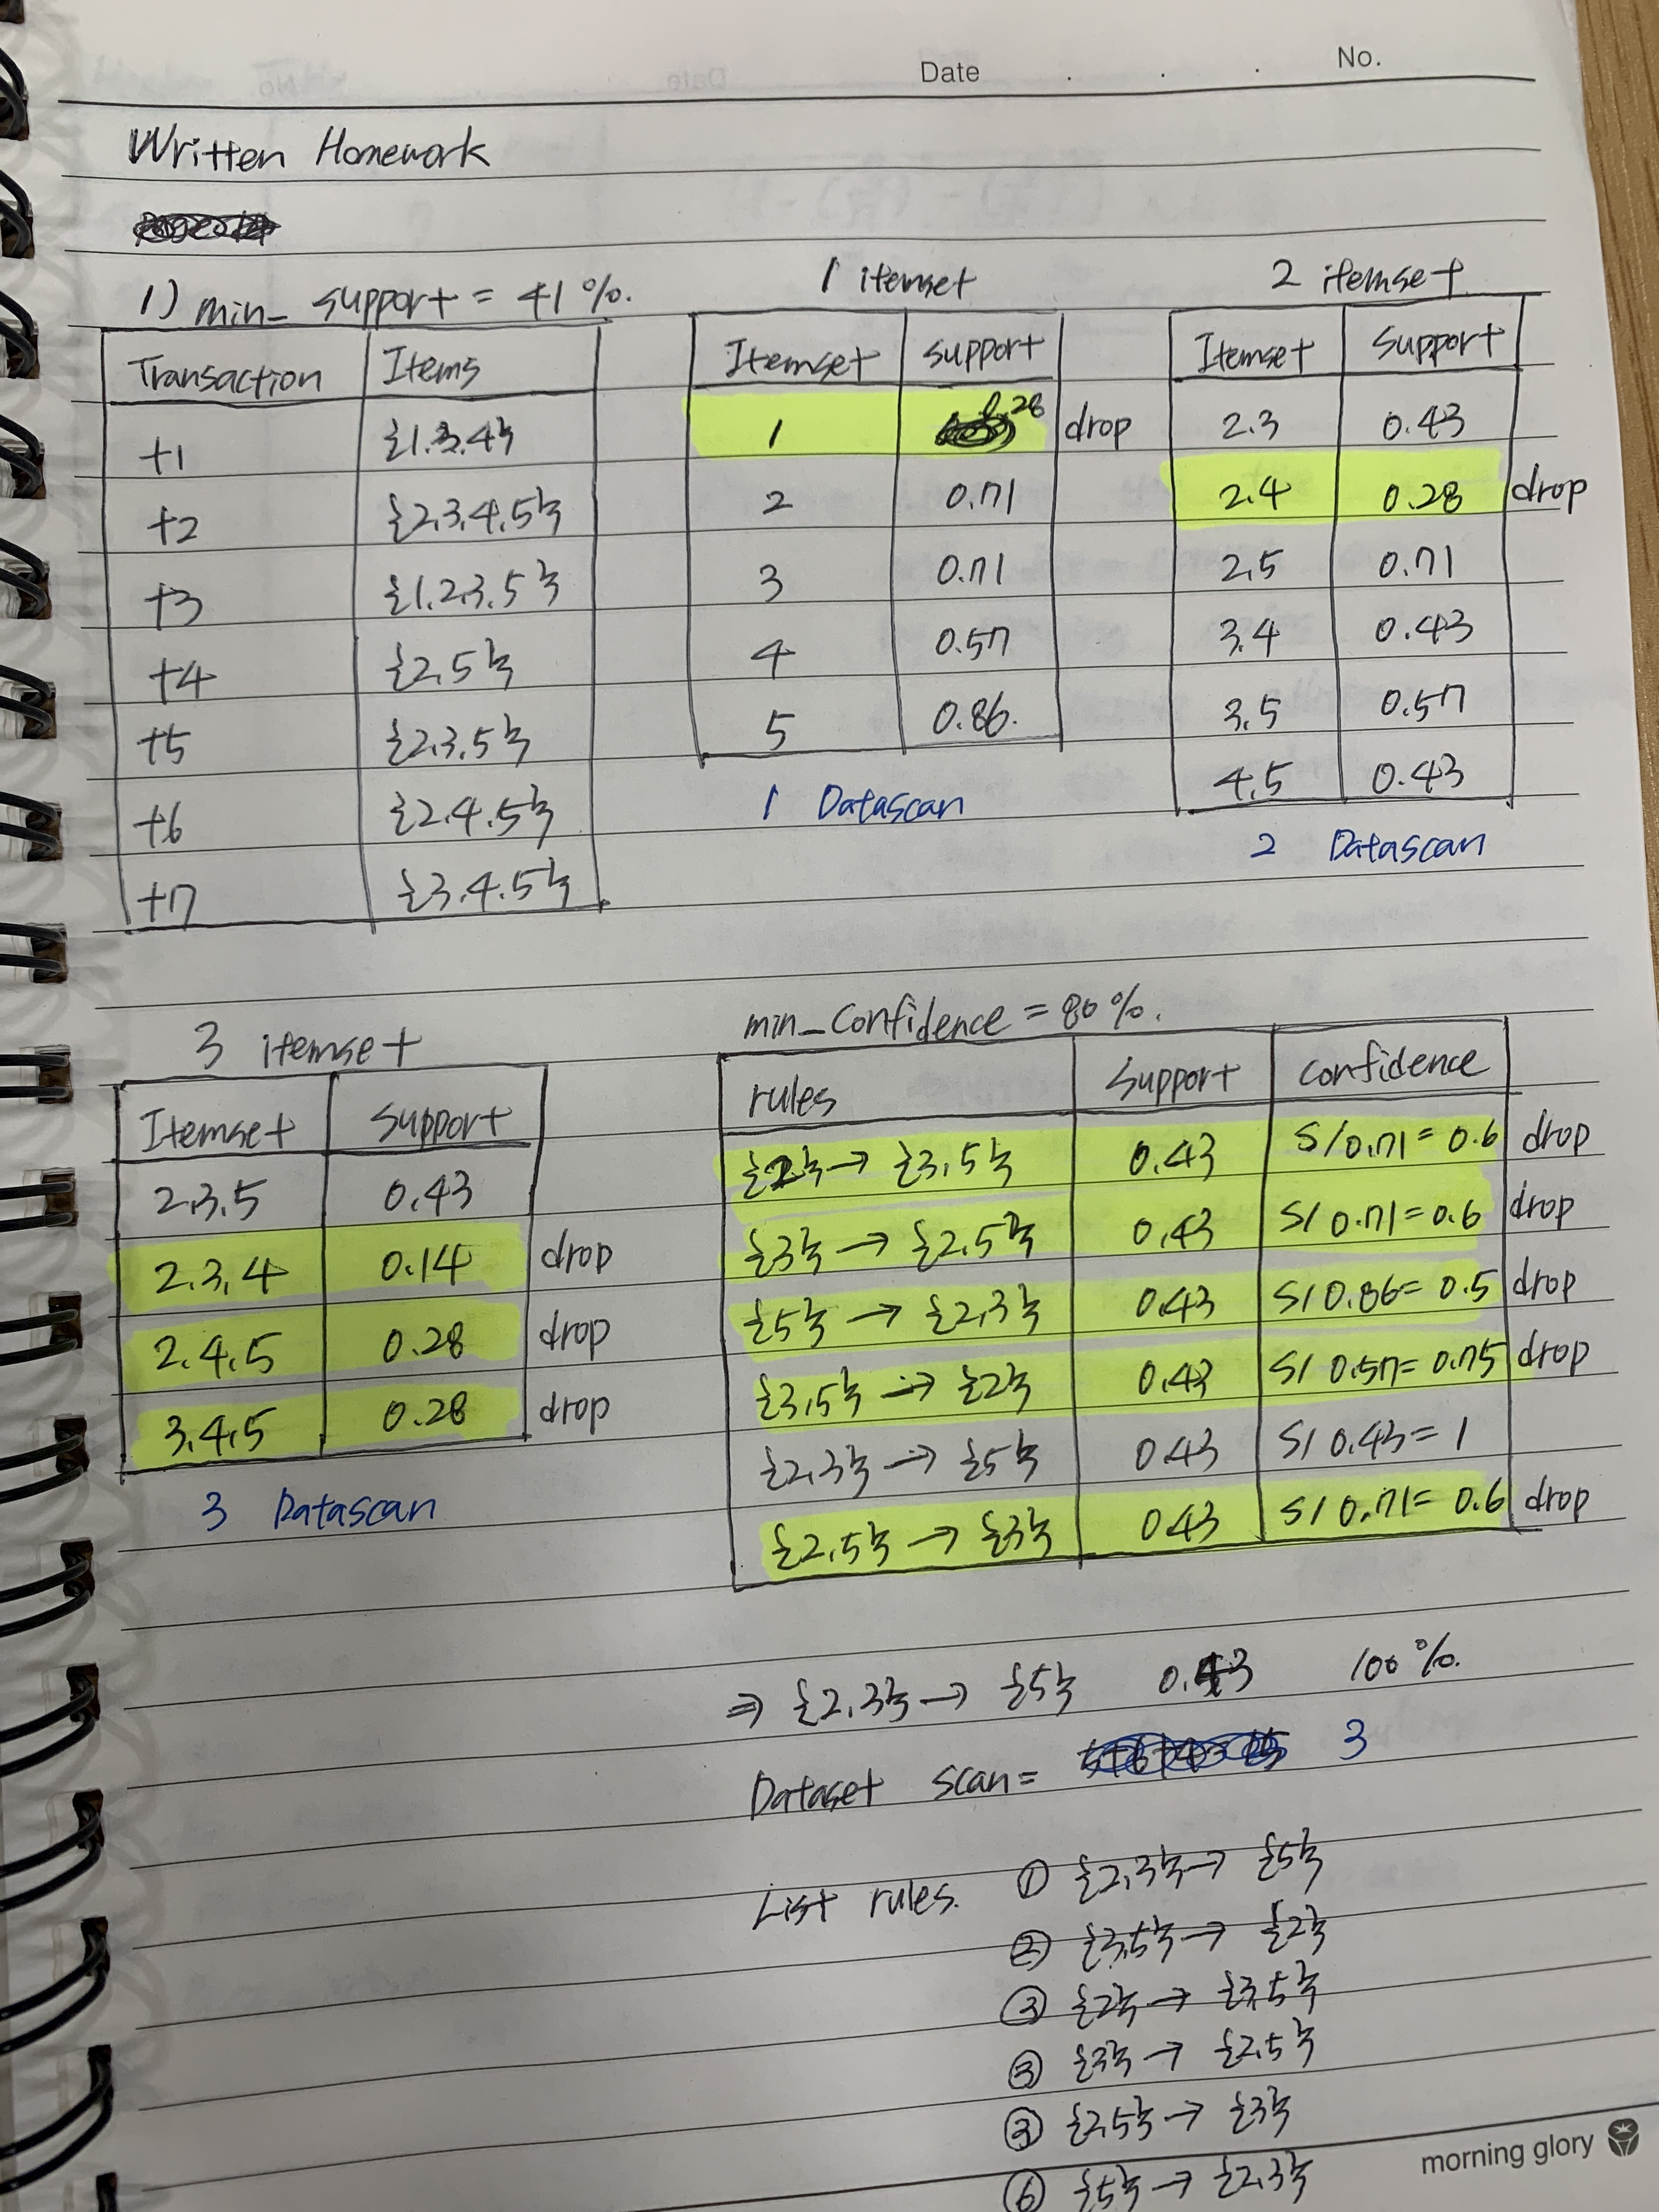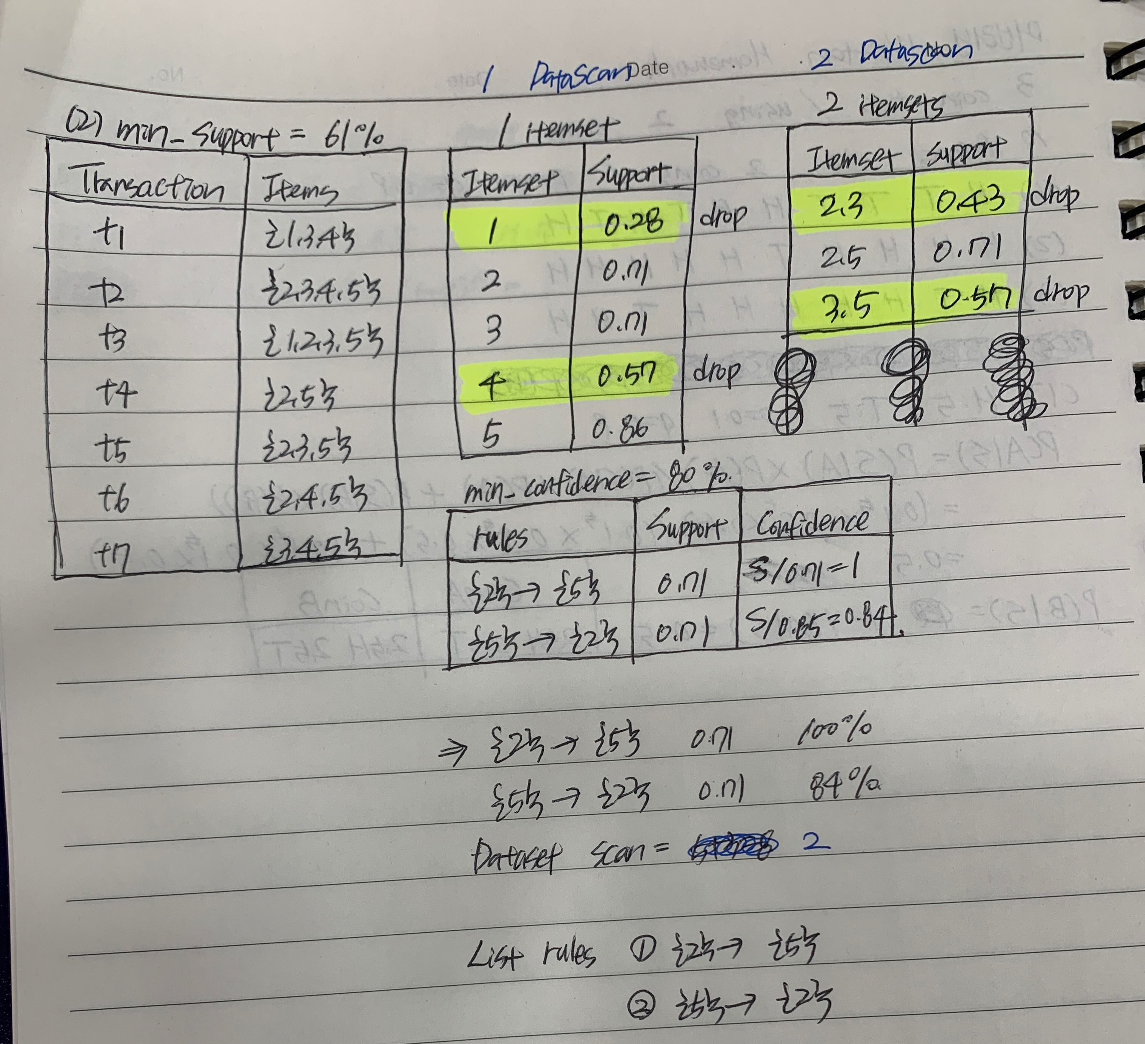

**2**

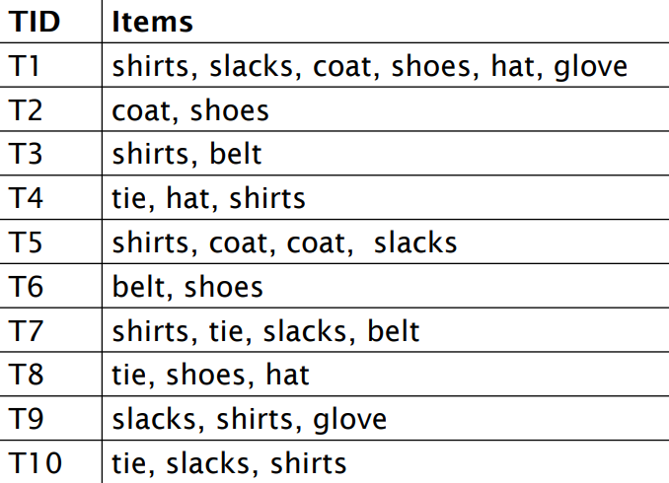

1 itemset

support threshold = 1/3,

confidence threshold = 50%

|  |  |  |
| --- | --- | --- |
| **Itemset** | **support** |  |
| shirts | 7/10 |  |
| slacks | 5/10 |  |
| coat | 3/10 | drop |
| shoes | 4/10 |  |
| hat | 3/10 | drop |
| glove | 2/10 | drop |
| belt | 3/10 | drop |
| tie | 4/10 |  |

2 itemset

|  |  |  |
| --- | --- | --- |
| **Itemset** | **support** |  |
| shirts, slacks | 5/10 |  |
| shirts, shoes | 1/10 | drop |
| shirts, tie | 3/10 | drop |
| slacks, shoes | 1/10 | drop |
| slacks, tie | 2/10 | drop |
| shoes, tie | 1/10 | drop |

|  |  |  |
| --- | --- | --- |
| **rules** | **support** | **confidence** |
| {shirts} -> {slacks} | 5/10 | 0.5/0.7=0.71 |
| {slacks} -> {shirts} | 5/10 | 0.5/0.5=1 |

=> {shirts} -> {slacks} 5/10 71%

{slacks} -> {shirts} 5/10 100%

Data scan = 2(when making itemset)

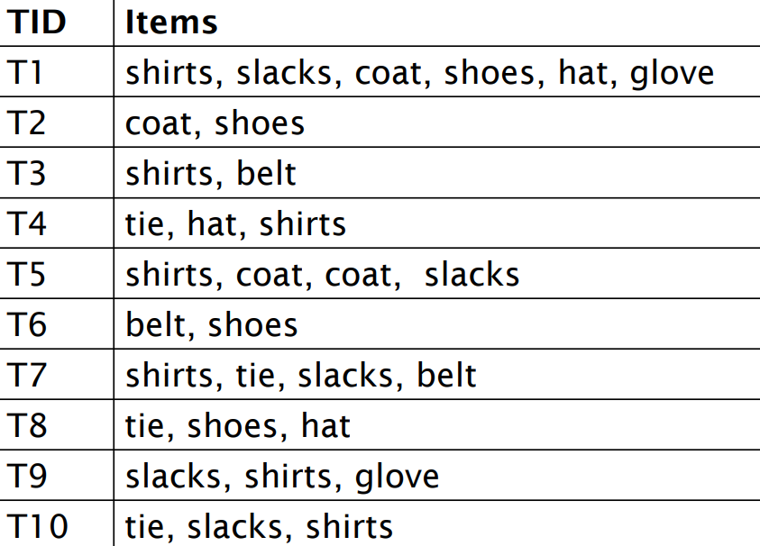**3**

|  |
| --- |
| **frequent items** |
| shirts, slacks, shoes |
| shoes |
| shirt |
| shirts, tie |
| shirts, slacks |
| shoes |
| shirts, slacks, tie |
| shoes, tie |
| shirts, slacks |
| shirts, slacks, tie |

f-list = shirts – slacks – shoes – tie

**Header Table**

|  |  |
| --- | --- |
| **Item** | **frequency** |
| shirts | 7 |
| slacks | 5 |
| shoes | 4 |
| tie | 4 |

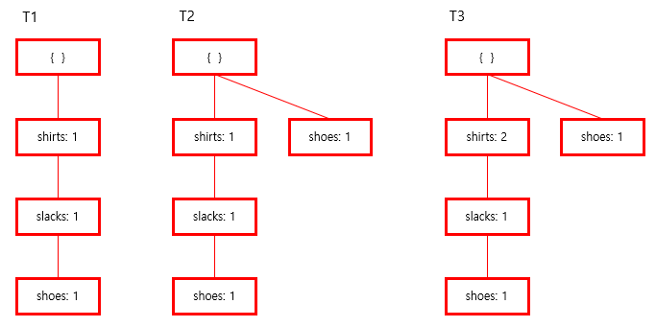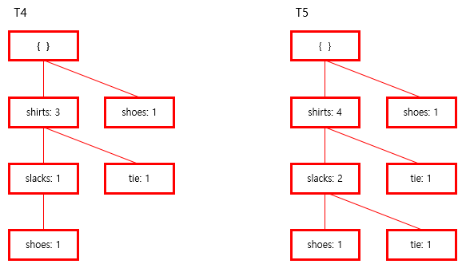

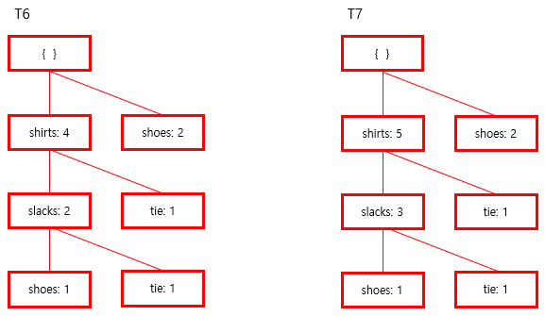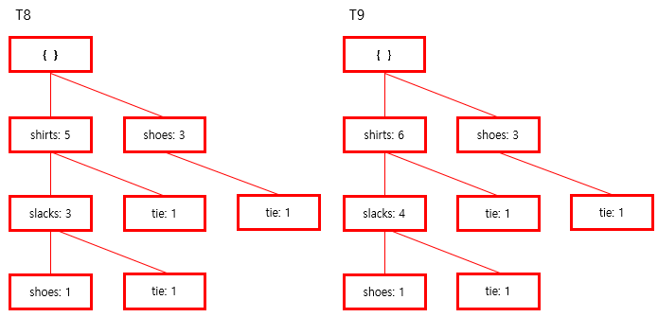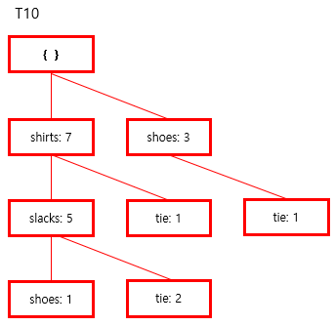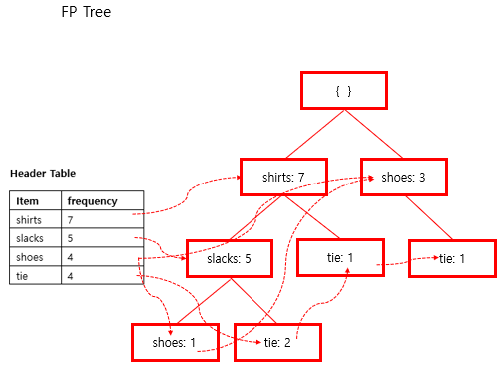

f-list = shirts – slacks – shoes – tie DataScan = 2

|  |  |
| --- | --- |
| Conditional Pattern Bases | |
| item | cond.pattern base |
| slacks | shirts(5) |
| shoes | shirts(1), slacks(1) |
| tie | shirts(1) slacks(1), shirts(1), shoes(1) |

